Joseph Silva Jr.

08/17/21

CS 340 – Assignment: 8

SNHU

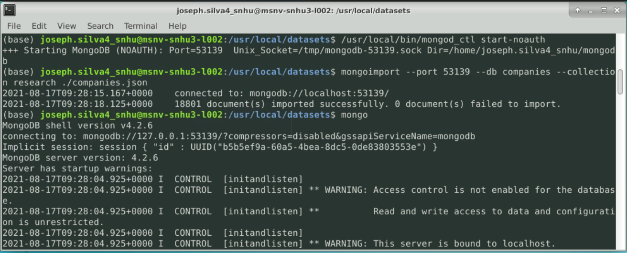

Search for any company in the using database collection (research) with the name “AdventNet”

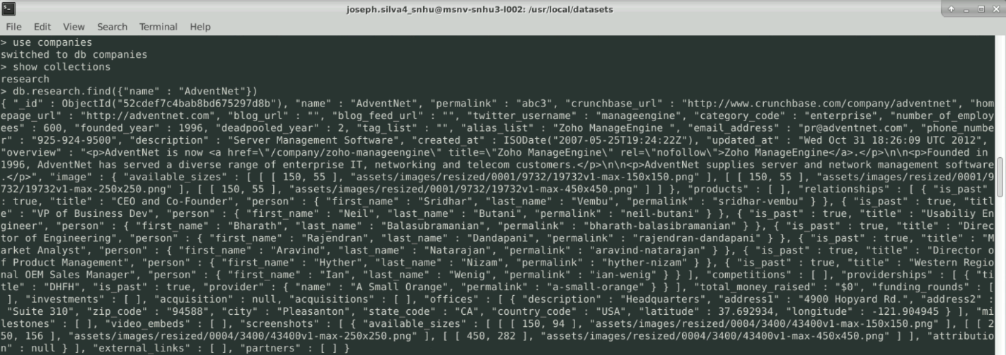

search for company and return names of companies with a founded_year: 1996. Limit to 10 companies.

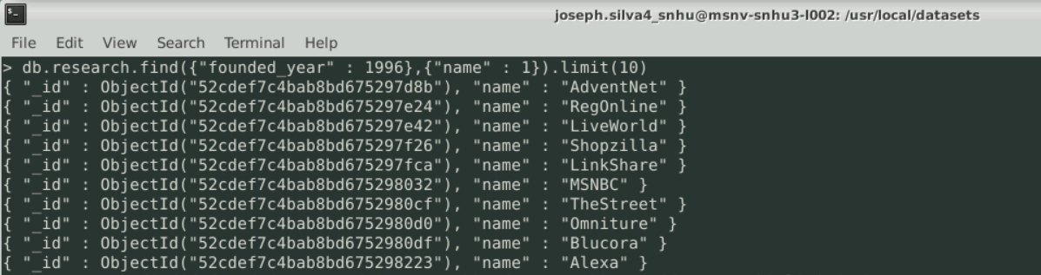

List only the first 20 names of companies founded after the year 2010, ordered alphabetically.

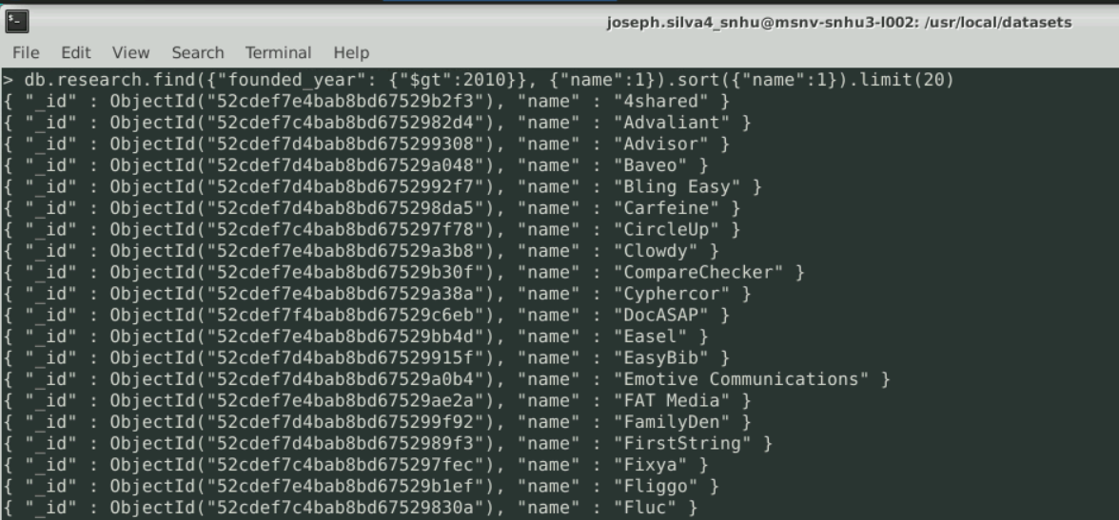

List only the first 20 names of companies with offices in either California or Texas, ordered by the number of employees and sorted largest to smallest.

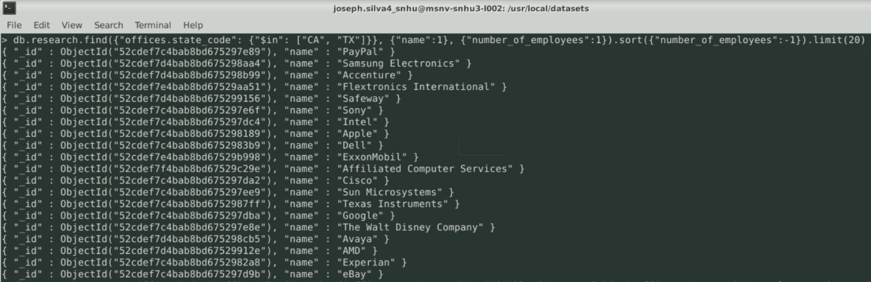

**Design and implement a MongoDB aggregation pipeline** to show the total number of employees by state for all companies that have offices in the United States.

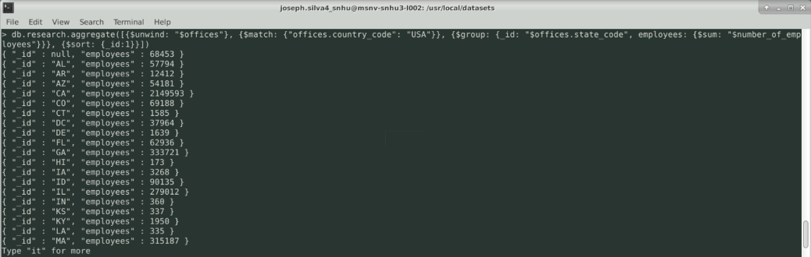

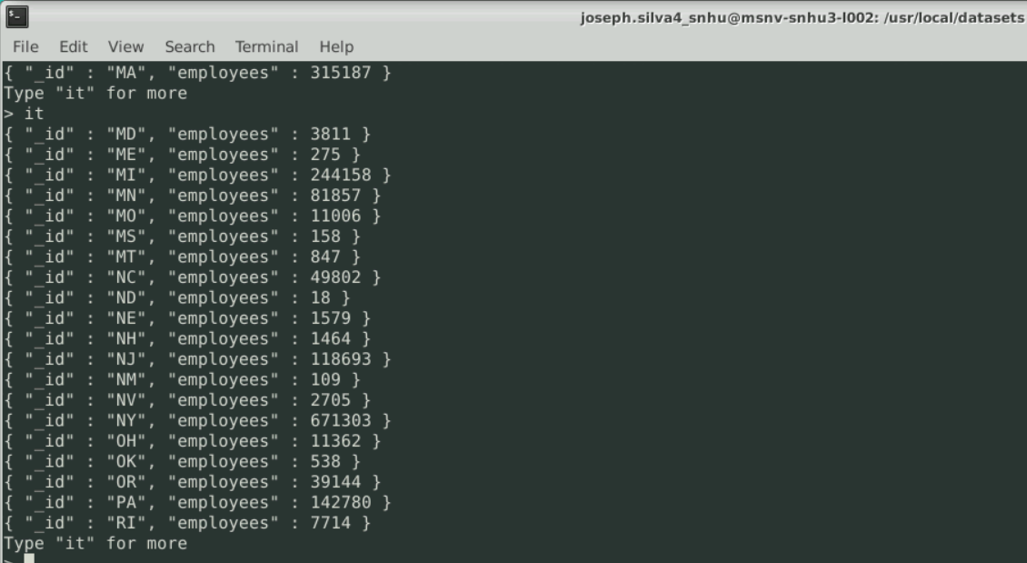

Shows the amount of employees within each State inside of the US.